**Creating the virtual machine image**

Creating a VM image is kind of creating a identical image of a running VM including all application, disk and configuration. This created image we can able to use to make new VM future use.

Note: important to note, after creating the image for a particular VM will no longer usable for any purpose. This is draw back for this image builder.

Before creating the image:

-create a VM

-access the VM via RDP port

-install IIS service on the vm

--make sure you have setup the rule port 80 for HTTP

-check the IIS using the public IP on browser.

-now go to this pc on VM.

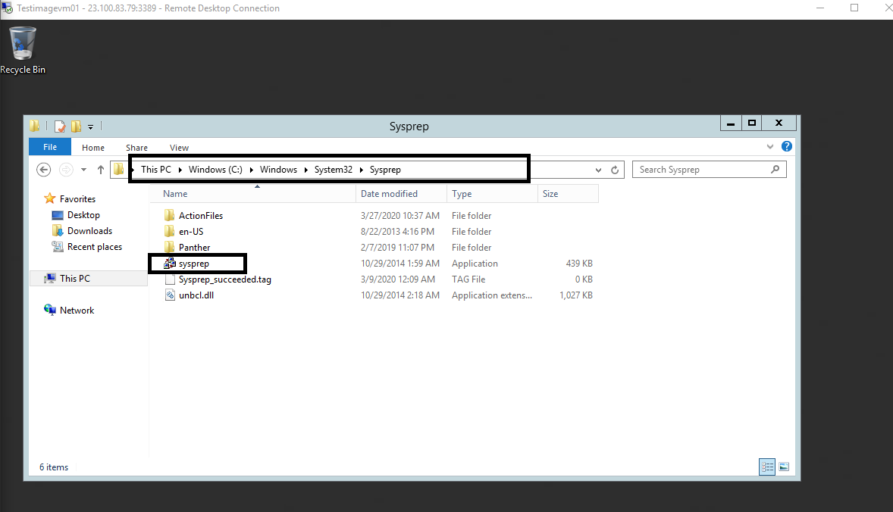

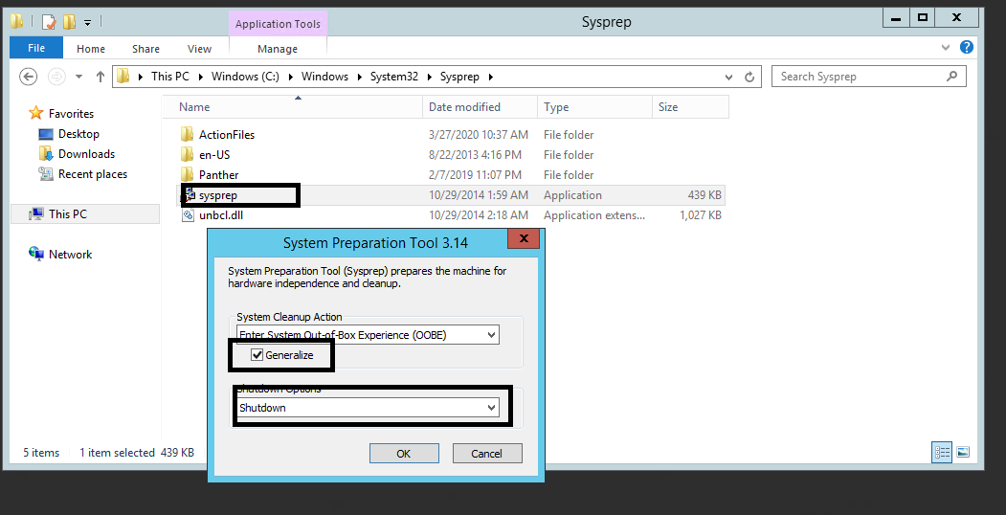

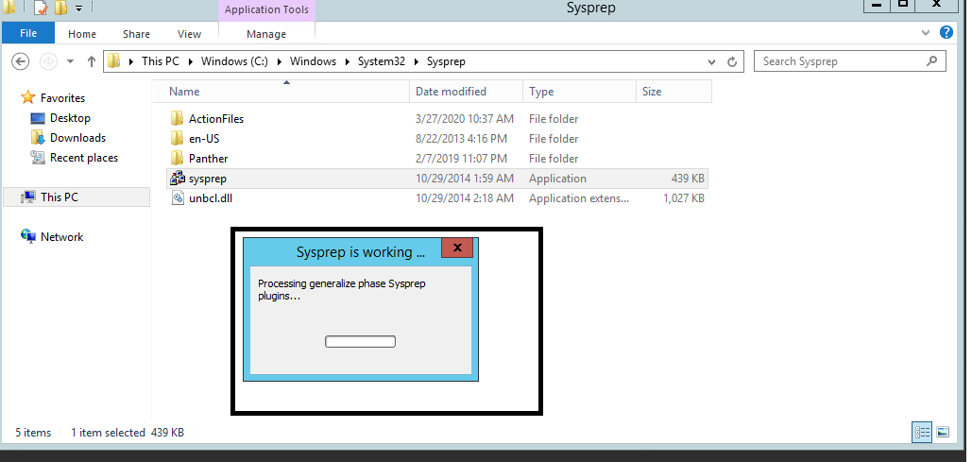

Stop-AzVM -ResourceGroupNmae rg01 -Nmae Testimagevm01 -Force

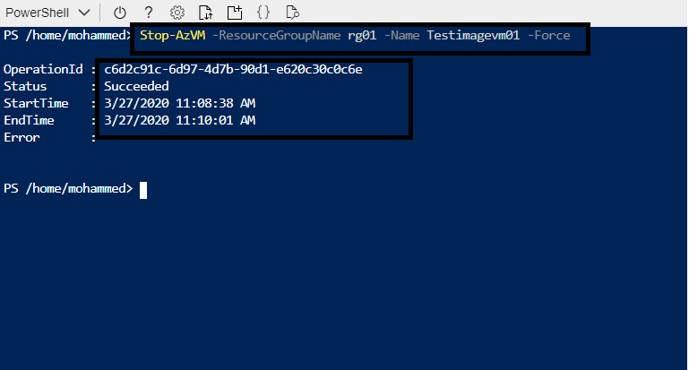

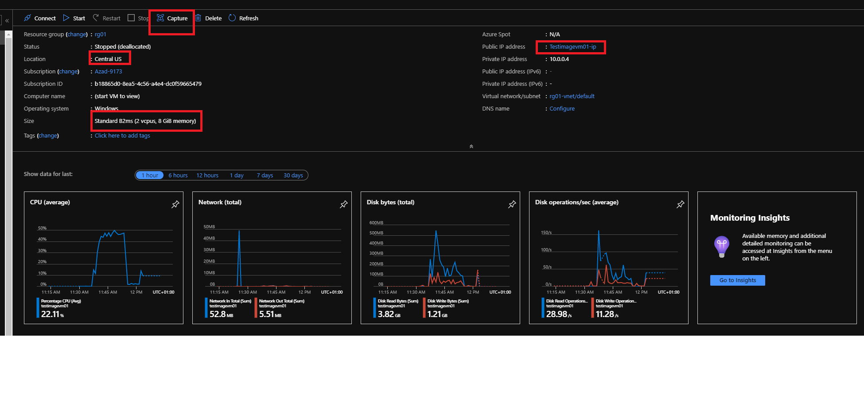

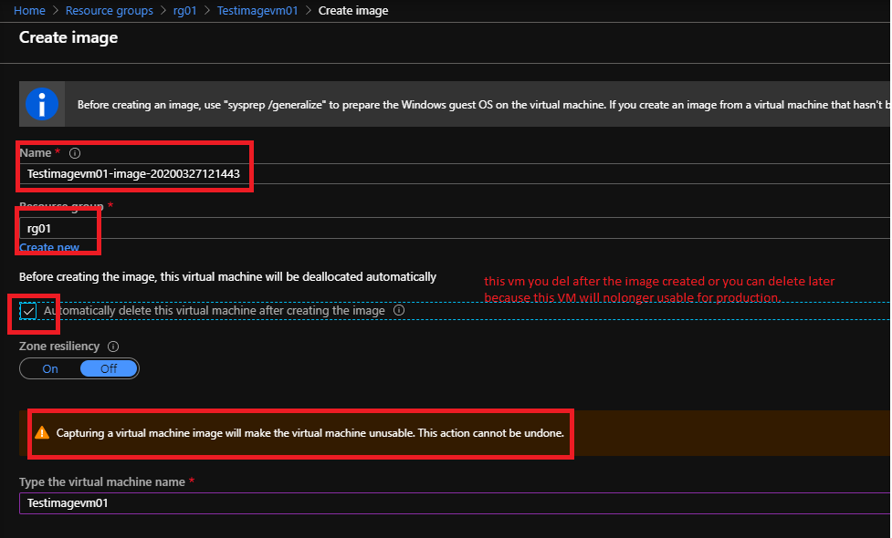

You can check the imaged from resource group or serch with Image.

Using the created image you able to deploy new identical VM for production environment.

